3G611R (3G611R+)-How to set port range forwarding?
Product line: 3G Question category: Function configurations

Q: why we want to configure port range forwarding?
A: Port Range Forwarding allows remote computers, for example, computers on the Internet to access some kinds of public services such as web servers, ftp, e-mail and other specialized Internet applications on your local network（LAN）.

The topology is as following:
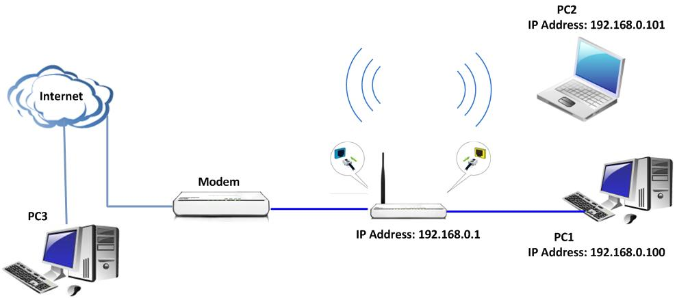
The steps are as below:
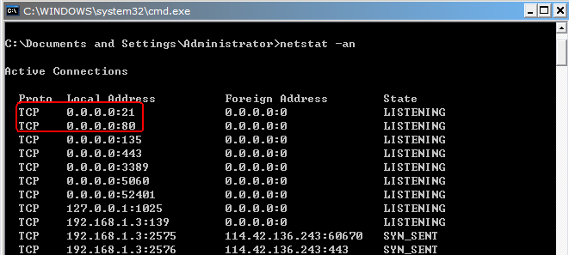
1. First you should run a server (e.g. FTP server) on your computer. Click start→run and type cmd in the blank. In the new window, please type netstat -an. Then you can check whether the FTP server has been run successfully.
2. On the PC1, You can enter ftp://192.168.0.100 in the address bar in web browser to check whether you can access the server in the same LAN.
3. Login the management page of the router. Then please click Virtual Server →Port Range Forwarding. Choose ftp (21) as well-known service ports. Type 100 in the blank of LAN IP and type 21 in the Start port and End port in the blank. Choose both as protocol and click enable. 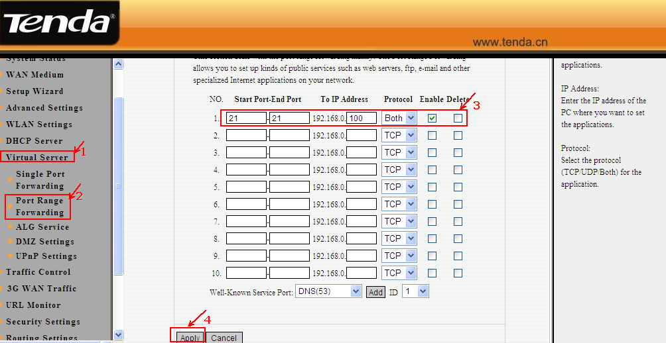
5. After you click ok to save the setting, you can access the FTP server of PC2. Please enter ftp://WAN IP (example: ftp://1.1.1.1) in the address bar to access the FTP Server.

